Capacitor Information
Due to changes in component suppliers your kit may have different styles of capacitors included.
Value | Ref | Marking | Image | Marking | Image
220nf | C3 | ‘.22K63’ | 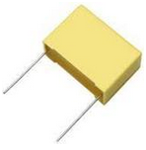 | ‘224’ | 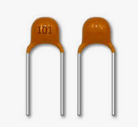
47nf | C4, C6 | ‘47nK100’ |  | ‘473’
2.2nf | C7 | ‘2n2K100’ |  | ‘222’
1.5nf | C8 | ‘152’ | Also in blue
100pf | C9, C16 | ‘101’ | 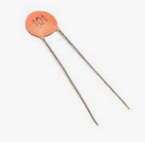 | ‘101’
1nf | C10 | ‘1nK100’ |  | ‘102’
33nf | C11, C17 | ‘33nK100’ | Also in dark grey | ‘333’
470pf | C12,C13 | ‘471’ |  | ‘471’
100nf | C14 | ‘.1K63’ or ‘.1J63‘ |  | ‘104’
100uf | C1, C2, C15 | ‘10V 100uf’ | 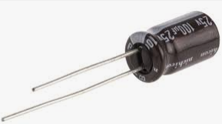 | Might have different voltages
220uf | C5 | ‘16V 220uf’ |  | Might have different voltages

Capacitor Information
Due to changes in component suppliers your kit may have different styles of capacitors included.
Value | Ref | Marking | Image | Marking | Image
220nf | C3 | ‘.22K63’ |  | ‘224’
47nf | C4, C6 | ‘47nK100’ |  | ‘473’
2.2nf | C7 | ‘2n2K100’ |  | ‘222’
1.5nf | C8 | ‘152’ | Also in blue
100pf | C9, C16 | ‘101’ |  | ‘101’
1nf | C10 | ‘1nK100’ |  | ‘102’
33nf | C11, C17 | ‘33nK100’ | Also in dark grey | ‘333’
470pf | C12,C13 | ‘471’ |  | ‘471’
100nf | C14 | ‘.1K63’ or ‘.1J63‘ |  | ‘104’
100uf | C1, C2, C15 | ‘10V 100uf’ |  | Might have different voltages
220uf | C5 | ‘16V 220uf’ |  | Might have different voltages

